Update info
AQUA DESIGNER
Version 9.1
Document: | Update info AQUA DESIGNER Version 9.1
Developed by: | BITControl GmbH  Auf dem Sauerfeld 20  54636 Nattenheim
Written by: | Dipl. Ing. Norbert Meyer
Written Date: | 04.10.2019
Version: | 01 from 04.10.2019

Table of Contents
1 Summary 2
2 New in AQUA DESIGNER version 9.1 2
3 New in AD 8.3 7
4 New in AD 8.2 8
5 Examples 9
5.1 Machine List 9
5.2 Measuring List 12
5.3 Flow Diagram 14
5.4 Drawing combined denitrification 15
5.5 Drawing clarifier 16

Summary
AQUA DESIGNER is one of the standard design programs for activated sludge plants in Germany and worldwide. The range of tools has been extended over the last few years to all important procedures and procedural stages.
- Sand trap as ventilated sand and fat catcher or round sand trap.
- Primary clarifier as rectangular or round basin.
- Aeration as continuous flow or SBR with common container shapes.
- Sludge treatment as anaerobic treatment or aerobic stabilization.

Many guidelines have been incorporated into the software:
- DWA-A 131, May 2016
- ATV-DVWK-A 198, April 2003
- DWA-A 202, May 2011
- DWA-M 210, July 2009
- DWA-A 226, August 2009
- DWA-M 229-1, September 2017
- DWA-M 368, June 2014
- DWA-M 260, October 2017
- DWA-M 227, October 2014; NEW

New in AQUA DESIGNER version 9.1
- New Standard M 227, Membrane Bioreactor

Since AQUA DESIGNER 9.0 very detailed ways of design for Membrane Bioreactor Plants is implemented. In AD 9.1 this part has been refined because of further demands and technical discussions.
The two common kinds of arrangement are available, modules in the activated chamber or modules in separate chambers.
The design is supported by standard values according to the M 227 and by data banks, containing membranes of suppliers, blowers for cross flow and pumps for permeat pumping.

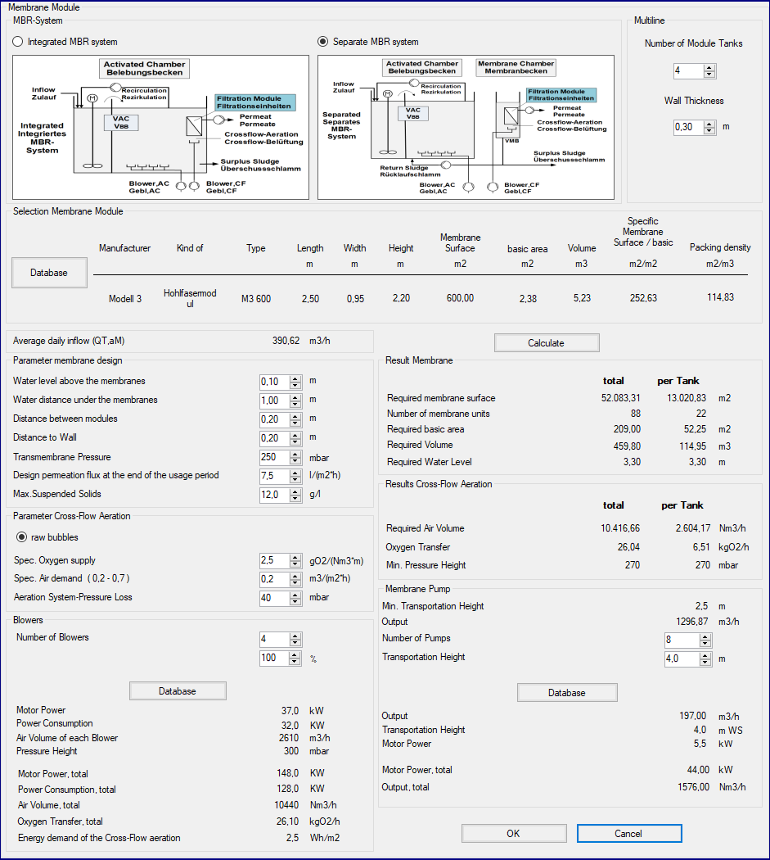
Figure 1: Selecting Modules and designing cross flow and permeat pumping

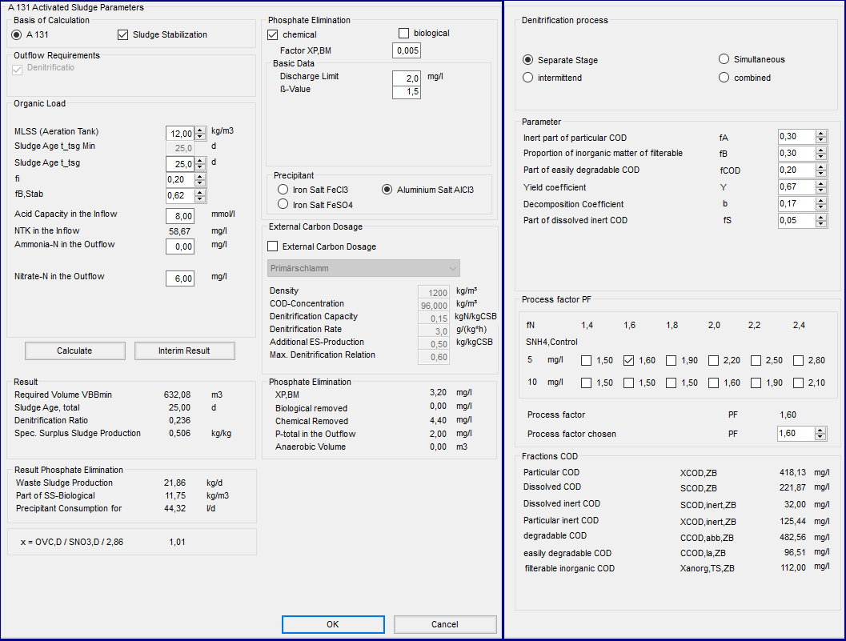
Figure 2: Biological Volume and Treatment Parameters

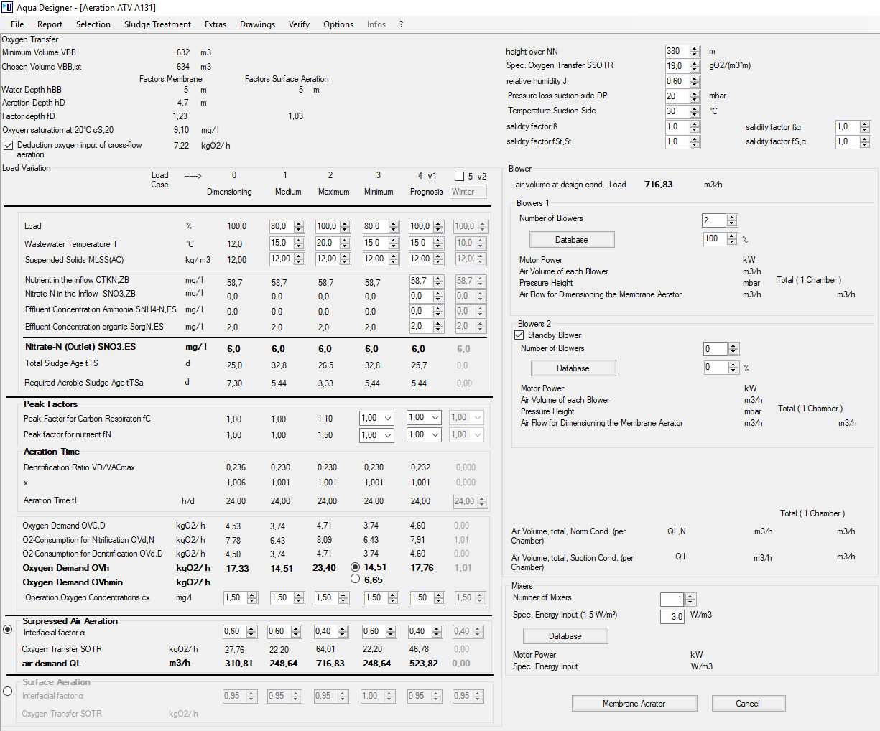
Figure 3: Evaluating the oxygen demand and designing the aeration equipment

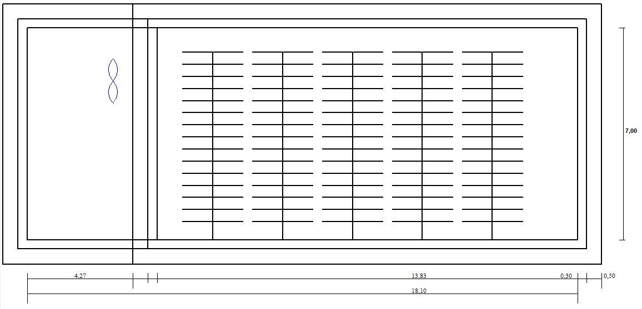
Figure 4: True scaled drawing of the activated chamber with equipment

After completing the design of a Membrane Bioreactor the additional tools are available.

Also for MBR you can add
- anaerobic or aerobic sludge treatment
- operational cost
- Oxygen efficiency
- Machine list
- And the other engineering tools of AQUA DESIGNER
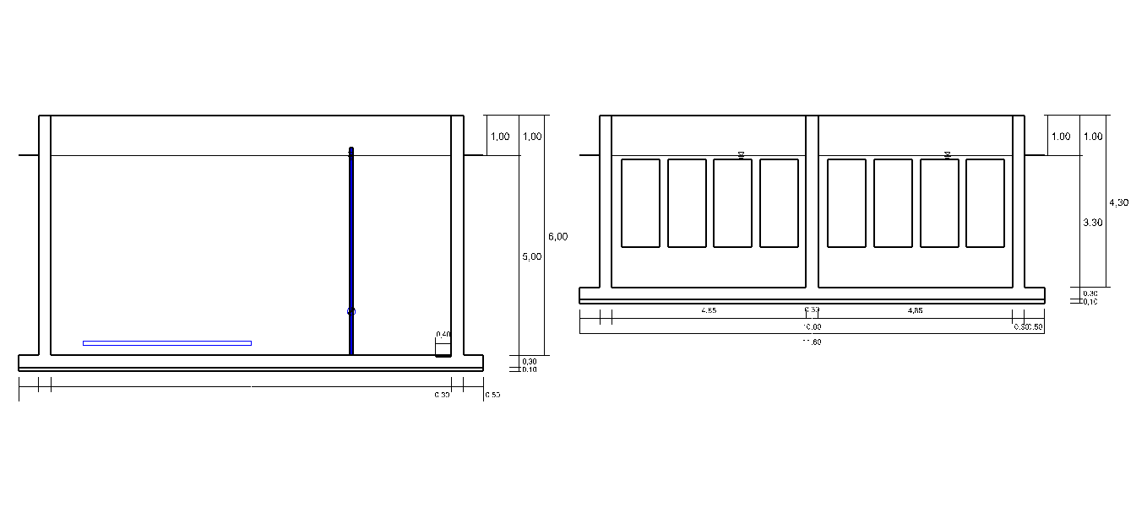
Figure 4: True scaled drawing, MBR side view

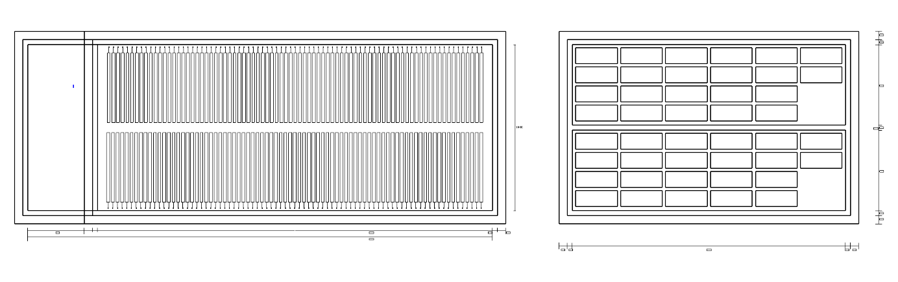
Figure 4: True scaled drawing, MBR top view

New in AD 8.3
- New Standard MSIG, Malaysian Sewerage Industry Guidelines
- New Standard Metcalf & Eddy for load, primary sedimentation and clarifiers
- Automatically generated machine and measuring list
- Automatically generated flow diagram
- Excel Export for the documentations
In the current update version 8.3, we added a Machine List and a Flow Diagram.

After completing a project design including sand- and grease chamber, primary sedimentation, activated chamber, clarifier and return sludge pumping you can add other process steps via the component selection.
The selected steps with a typical set of machines and all the machine data chosen during the design process are listed in the machine list. Also for the measuring equipment a list can be generated. Part of this is also a plant identification system. By this index every machine can be identified in the lists and in the flow diagram.
Based on the design and the selections a flow diagram is generated suitable to the way of calculation.

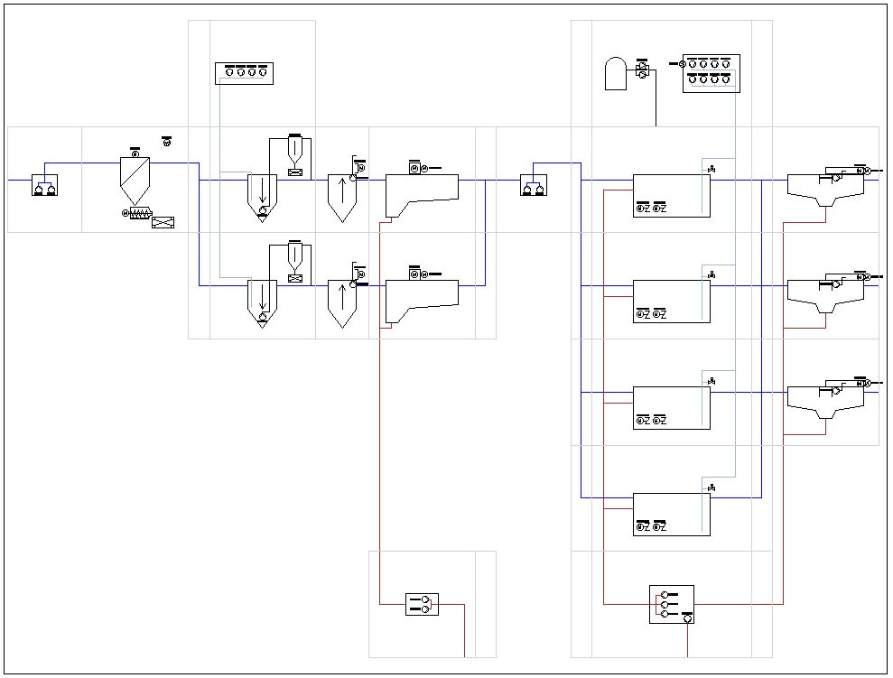
Figure 5: Flow Diagram Water Line

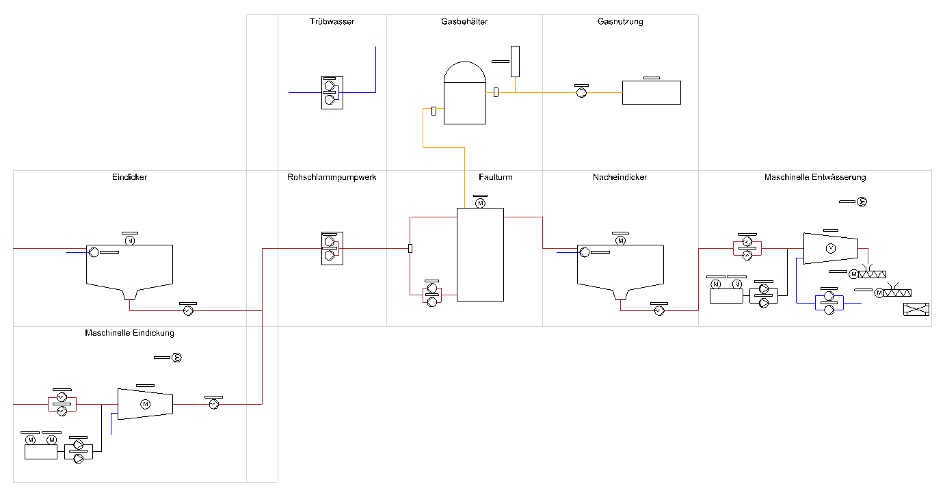
Figure 5: Flow Diagram Sludge Treatment

See also on youtube at https://www.youtube.com/watch?v=-uhVsin2rDM

New in AD 8.2
Continuous adaptation and improvement of the Design and SBR systems through the standard DWA-M 229-1. The following changes have been introduced into leaflet DWA-M 229-1:
- Case 3: The minimum air volume is calculated using a different approach.
- SOTR: The necessary oxygen supply SOTR was modified in particular with regard to the salt content.
- Operating air quantity Q1: The formula for the operating air quantity Q has not been changed.
- This applies to the design of SBR systems.
The modified formulas are listed in detail in the manual for the current version.

Examples

Machine List
Nr | Process stage | Order Number | Name | Type | Motor Power  [kW] | Power  Consumption  [kW] | Capacity | Capacity  Unit
1 | Inflow Pumping Station | M-IN-P.1 | Inlet Pump.1 | Centrifugal Pump |  |  | 3.255,21 | m³/h
2 | Inflow Pumping Station | M-IN-P.2 | Inlet Pump.2 | Centrifugal Pump |  |  | 3.255,21 | m³/h
3 | Screen | M-SCR-SCR.1 | Screen.1 | Step Screen with Press |  |  | 6.510,42 | m³/h
4 | Screen | M-SCR-VE.1 | Screen Ventilator.1 | Ventilator
5 | Grit and Grease Chamber | M-GC-B.1 | Grit Blower.1 | GM 4 S | 7,5 | 5,4 | 273,6 | m3/h
6 | Grit and Grease Chamber | M-GC-B.2 | Grit Blower.2 | GM 4 S | 7,5 | 5,4 | 273,6 | m3/h
 | ..............................
17 | Pre Sedimentation | M-PS-PSP.1 | Primary Sludge Pump.1 | Centrifugal Pump
18 | Pre Sedimentation | M-PS-PSP.2 | Primary Sludge Pump.2 | Centrifugal Pump
19 | Pre Sedimentation | M-PS-SR.1.1 | Sludge Removal Device.1.1 | Sludge Removal Device
20 | Pre Sedimentation | M-PS-SR.2.1 | Sludge Removal Device.2.1 | Sludge Removal Device
 | ..............................
25 | Intermediate Pumping Station | M-INT-P.1 | Intermediate Pump.1 | Centrifugal Pump |  |  | 3.255,21 | m³/h
26 | Intermediate Pumping Station | M-INT-P.2 | Intermediate Pump.2 | Centrifugal Pump |  |  | 3.255,21 | m³/h
27 | Anaerobic Mix Tank | M-AMT-MR.1.1 | Anaerobic Mix Tank Mixer.1.1 | Mixers |  |  |  | kW
28 | Anaerobic Mix Tank | M-AMT-MR.1.2 | Anaerobic Mix Tank Mixer.1.2 | Mixers |  |  |  | kW
 | ..............................
36 | Activated Chamber | M-AC-B.1 | Blower.1 | GM 50 L | 75 | 63,7 | 3.048,00 | m³/h
37 | Activated Chamber | M-AC-B.2 | Blower.2 | GM 50 L | 75 | 63,7 | 3.048,00 | m³/h
38 | Activated Chamber | M-AC-B.3 | Blower.3 | GM 50 L | 75 | 63,7 | 3.048,00 | m³/h
39 | Activated Chamber | M-AC-B.4 | Blower.4 | GM 50 L | 75 | 63,7 | 3.048,00 | m³/h
 | ..............................
48 | Activated Chamber | M-AC-VE.1 | Activated Chamber Ventilator.1 | Ventilator
49 | Activated Chamber | M-AC-MR.1.1 | Activated Chamber Mixer.1.1 | EMU TR 325 | 4,5 | 14,86 | 1,72 | W/m³
50 | Activated Chamber | M-AC-MR.1.2 | Activated Chamber Mixer.1.2 | EMU TR 325 | 4,5 | 14,86 | 1,72 | W/m³
 | ..............................
61 | Precipitant dosage | M-PD-MNP.1 | Precipitant Dosage Pump.1 | Membrane Pump
62 | Precipitant dosage | M-PD-MNP.2 | Precipitant Dosage Pump.2 | Membrane Pump
63 | Secondary Settling Tank | M-SS-SR.1.1 | Secondary Sedimentation Scraper.1.1 | Remover Motor |  |  | 1 | kW
64 | Secondary Settling Tank | M-SS-SR.2.1 | Secondary Sedimentation Scraper.2.1 | Remover Motor |  |  | 1 | kW
 | ..............................
67 | Secondary Settling Tank | M-SS-SCP.1.1 | Scum Pump.1.1 | Scum Pump |  |  | 20 | m³/h
68 | Secondary Settling Tank | M-SS-SCP.2.1 | Scum Pump.2.1 | Scum Pump |  |  | 20 | m³/h
 | ..............................
71 | Secondary Settling Tank | M-SS-CC.1.1 | Channel Cleaning.1.1 | Channel Cleaning
72 | Secondary Settling Tank | M-SS-CC.2.1 | Channel Cleaning.2.1 | Channel Cleaning
 | ..............................
75 | Return Sludge Pump Station | M-RAS-P.1 | Return Sludge Pump.1 | Centrifugal Pump | 25 | 20 | 650 | m³/h
76 | Return Sludge Pump Station | M-RAS-P.2 | Return Sludge Pump.2 | Centrifugal Pump | 25 | 20 | 650 | m³/h
 | ..............................
85 | Waste Sludge Pumps | M-ES-P.1 | Excess Sludge Pump.1 | Centrifugal Pump
86 | Activated Chamber | M-AC-RCP.1 | Recirculation Pump.1 | Recirculation |  |  |  | m³/h
87 | Activated Chamber | M-AC-RCP.2 | Recirculation Pump.2 | Recirculation |  |  |  | m³/h
 | ..............................
92 | Thickener | M-PTH-MR.1 | Thickener Mixer.1 | Mixer
93 | Thickener | M-PTH-PCP.1 | Thickener progressing cavity pump.1 | progr. cav. Pump
94 | Thickener | M-PTH-SN-P.1 | Thickener Supernatant Pump.1 | Centrifugal Pump
95 | Mechanical Thickening | M-MTH-DSP.1 | Thin sludge Pump.1 | Thin sludge Pump
96 | Mechanical Thickening | M-MTH-DSP.2 | Thin sludge Pump.2 | Thin sludge Pump
97 | Mechanical Thickening | M-MTH-TM.1 | Thickening Machine.1 | Thickening Machine
98 | Mechanical Thickening | M-MTH-TSP.1 | Thick Sludge Pump.1 | Thick Sludge Pump
99 | Mechanical Thickening | M-MTH-POM.1 | Mixer Polymer.1 | Polymer
100 | Mechanical Thickening | M-MTH-POM.2 | Mixer Polymer.2 | Polymer
101 | Mechanical Thickening | M-MTH-PDP.1 | Polymer Dosage Pump.1 | Polymer Dosage Pump
102 | Mechanical Thickening | M-MTH-PDP.2 | Polymer Dosage Pump.2 | Polymer Dosage Pump
103 | Mechanical Thickening | M-MTH-VE.1 | Mechanical Thickening Ventilator.1 | Ventilator
104 | Raw Sludge | M-RMS-P.1 | Raw Sludge Pump.1 | Raw Sludge Pump
105 | Raw Sludge | M-RMS-P.2 | Raw Sludge Pump.2 | Raw Sludge Pump
106 | Digester | M-DP-PC.1 | Digester Circulating Pump.1 | Circulating Pump
107 | Digester | M-DP-PC.2 | Digester Circulating Pump.2 | Circulating Pump
108 | Digester | M-DP-MR.1 | Digester Mixer.1 | Mixer
109 | Secondary Thickener | M-STH-MR.1 | Secondary Thickener Mixer.1 | Mixer
110 | Secondary Thickener | M-STH-PCP.1 | Secondary Thickener progressing cavity pump.1 | progr. cav. Pump
111 | Secondary Thickener | M-STH-SN-P.1 | Secondary Thickener Supernatant Pump.1 | Centrifugal Pump
112 | Dewatering | M-DW-PFE.1 | Feed Pump.1 | progr. cav. Pump
113 | Dewatering | M-DW-PFE.2 | Feed Pump.2 | progr. cav. Pump
114 | Dewatering | M-DW-M.1 | Dewatering Machine.1 | Dewatering Machine
115 | Dewatering | M-DW-SSC.1 | Screw Conveyor.1 | Screw Conveyor
116 | Dewatering | M-DW-SSC.2 | Screw Conveyor.2 | Screw Conveyor
117 | Dewatering | M-DW-FIP.1 | Filtrate Pump.1 | Filtrate Pump
118 | Dewatering | M-DW-FIP.2 | Filtrate Pump.2 | Filtrate Pump
119 | Dewatering | M-DW-VE.1 | Dewatering Ventilator.1 | Ventilator
120 | Dewatering | M-DW-POM.1 | Dewatering Mixer Polymer.1 | Polymer
121 | Dewatering | M-DW-POM.2 | Dewatering Mixer Polymer.2 | Polymer
 | ..............................
124 | Supernatant | M-SN-P.1 | Supernatant Pump.1 | Centrifugal Pump
125 | Supernatant | M-SN-P.2 | Supernatant Pump.2 | Centrifugal Pump

Measuring List
Nr | Process stage | Process stage | Order Number | Measuring Point (*)
1 |  | Inflow Measuring | MES-IN.1 | Flow
2 |  | Inflow Measuring | MES-IN.2 | Conductivity
3 |  | Inflow Measuring | MES-IN.3 | PH
4 |  | Inflow Measuring | MES-IN.4 | NH4
5 |  | Inflow Pumping Station | MES-IN-PS.1 | Flow
6 |  | Inflow Pumping Station | MES-IN-PS.2 | Level
7 |  | Screen | MES-SCR.1 | Level
8 |  | Activated Chamber | MES-AC.1.1 | PH
9 |  | Activated Chamber | MES-AC.1.2 | Temperature
10 |  | Activated Chamber | MES-AC.1.3 | O2
11 |  | Activated Chamber | MES-AC.1.4 | NH4
12 |  | Activated Chamber | MES-AC.1.5 | NO3
13 |  | Activated Chamber | MES-AC.1.6 | MLSS
14 |  | Activated Chamber | MES-AC.1.7 | Pressure
15 |  | Activated Chamber | MES-AC.2.1 | PH
16 |  | Activated Chamber | MES-AC.2.2 | Temperature
17 |  | Activated Chamber | MES-AC.2.3 | O2
18 |  | Activated Chamber | MES-AC.2.4 | NH4
19 |  | Activated Chamber | MES-AC.2.5 | NO3
20 |  | Activated Chamber | MES-AC.2.6 | MLSS
21 |  | Activated Chamber | MES-AC.2.7 | Pressure
22 |  | Activated Chamber | MES-AC.3.1 | PH
23 |  | Activated Chamber | MES-AC.3.2 | Temperature
24 |  | Activated Chamber | MES-AC.3.3 | O2
25 |  | Activated Chamber | MES-AC.3.4 | NH4
26 |  | Activated Chamber | MES-AC.3.5 | NO3
27 |  | Activated Chamber | MES-AC.3.6 | MLSS
28 |  | Activated Chamber | MES-AC.3.7 | Pressure
29 |  | Activated Chamber | MES-AC.4.1 | PH
30 |  | Activated Chamber | MES-AC.4.2 | Temperature
31 |  | Activated Chamber | MES-AC.4.3 | O2
32 |  | Activated Chamber | MES-AC.4.4 | NH4
33 |  | Activated Chamber | MES-AC.4.5 | NO3
34 |  | Activated Chamber | MES-AC.4.6 | MLSS
35 |  | Activated Chamber | MES-AC.4.7 | Pressure
36 |  | Activated Chamber | MES-AC.5.1 | PH
37 |  | Activated Chamber | MES-AC.5.2 | Temperature
38 |  | Activated Chamber | MES-AC.5.3 | O2
39 |  | Activated Chamber | MES-AC.5.4 | NH4
40 |  | Activated Chamber | MES-AC.5.5 | NO3
41 |  | Activated Chamber | MES-AC.5.6 | MLSS
42 |  | Activated Chamber | MES-AC.5.7 | Pressure
43 |  | Activated Chamber | MES-AC.6.1 | PH
44 |  | Activated Chamber | MES-AC.6.2 | Temperature
45 |  | Activated Chamber | MES-AC.6.3 | O2
46 |  | Activated Chamber | MES-AC.6.4 | NH4
47 |  | Activated Chamber | MES-AC.6.5 | NO3
48 |  | Activated Chamber | MES-AC.6.6 | MLSS
49 |  | Activated Chamber | MES-AC.6.7 | Pressure
50 |  | Secondary Sedimentation | MES-SS.1 | Flow
51 |  | Return Sludge Pump Station | MES-RAS-PS.1.1 | Level
52 |  | Return Sludge Pump Station | MES-RAS-PS.2.1 | Level
53 |  | Return Sludge Pump Station | MES-RAS-PS.3.1 | Level
54 |  | Return Sludge Pump Station | MES-RAS-PS.4.1 | Level
55 |  | Thickener | MES-PTH.1 | Level
56 |  | Excess Sludge Thickening | MES-MTH.1 | Flow
57 |  | Excess Sludge Thickening | MES-MTH.2 | MLSS
58 |  | Raw Sludge | MES-RMS-PS.1 | Flow
59 |  | Raw Sludge | MES-RMS-PS.2 | Level
60 |  | Raw Sludge | MES-RMS-PS.3 | Phosphate
61 |  | Raw Sludge | MES-RMS-PS.4 | MLSS
62 |  | Digester | MES-DP.1 | Level
63 |  | Digester | MES-DP.2 | PH
64 |  | Digester | MES-DP.3 | Temperature
65 |  | Sludge Dewatering | MES-DW.1 | Flow
66 |  | Sludge Dewatering | MES-DW.2 | Level
67 |  | Sludge Dewatering | MES-DW.3 | MLSS
68 |  | Supernatant | MES-SN.1 | Level

Flow Diagram

Drawing combined denitrification
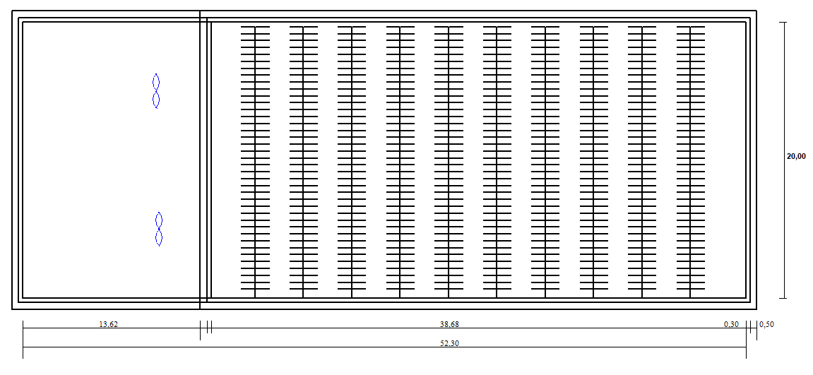

Drawing clarifier
